Edition

LONGMAN Welcome

to English

|  |
| --- |
| PEARSON  Longman |

DON DALLAS LINDA PELHAM

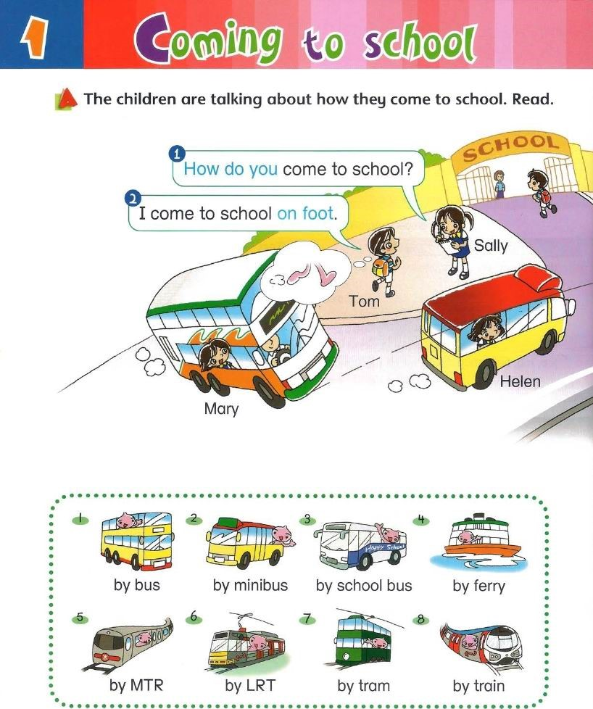

• Act the children. Ask and answer questions.

 How do you sally

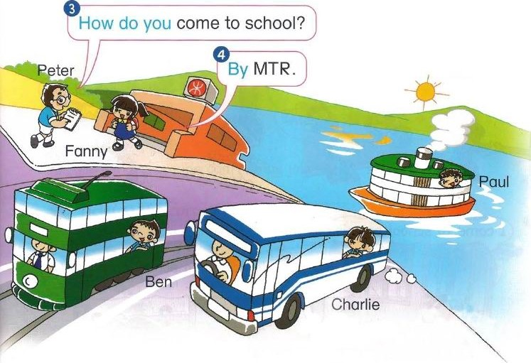I come

Mary

# El

Helen Ben Charlie Paul

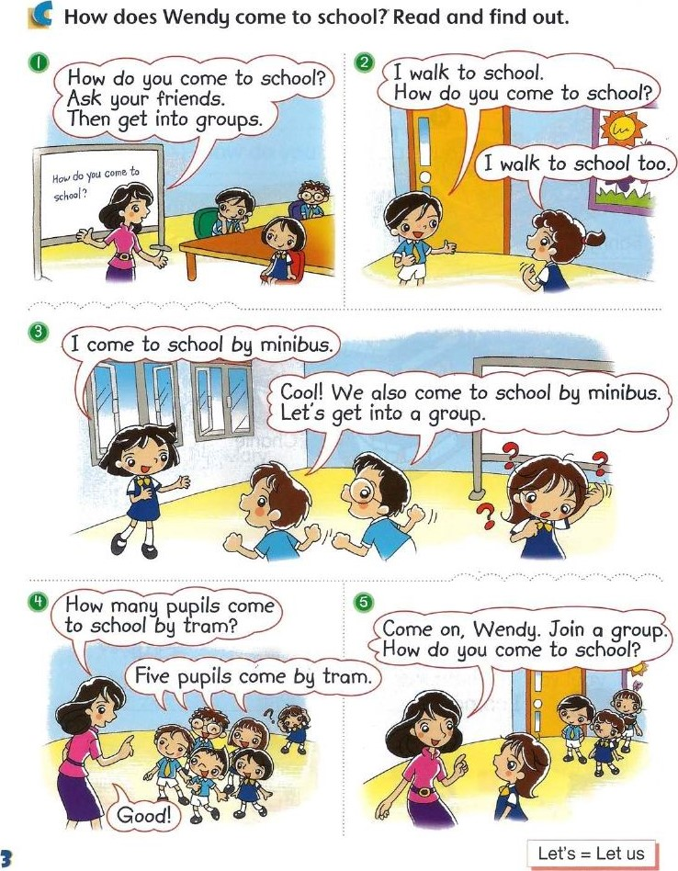

A

N

to

Read

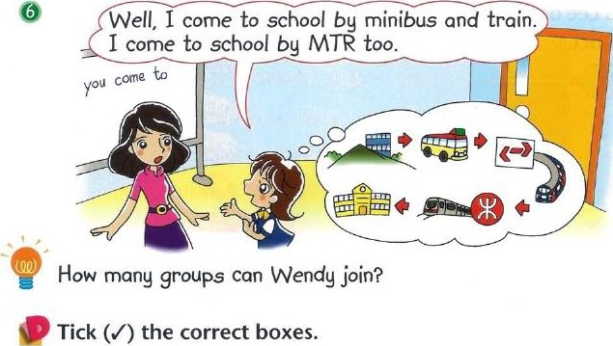

n

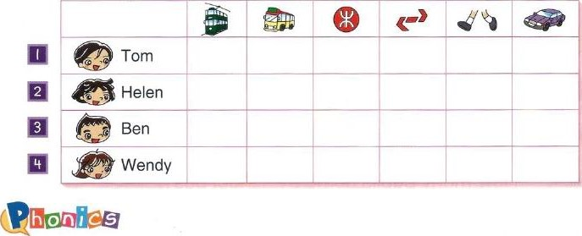

Say

the

sounds

and

the

words.

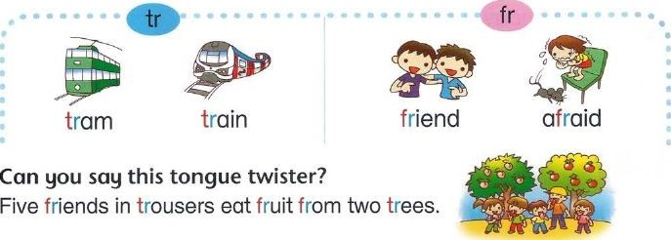

Miss Lee and Tom are talking about the survey. Look at the chart

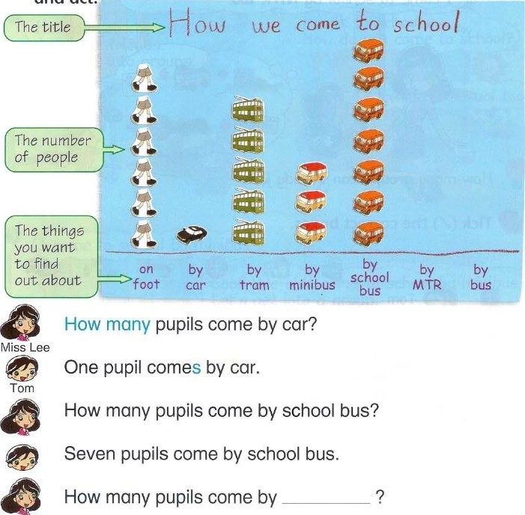

and

act.

Listen and finish the chart. How many pupils come by MTR and by bus?

Find out how your friends come to school. Make a chart.

## ang uage

Get into groups. Sing the song.

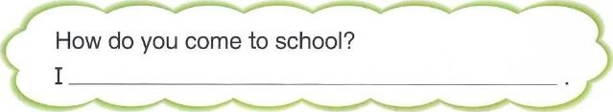HOW do you come to school?

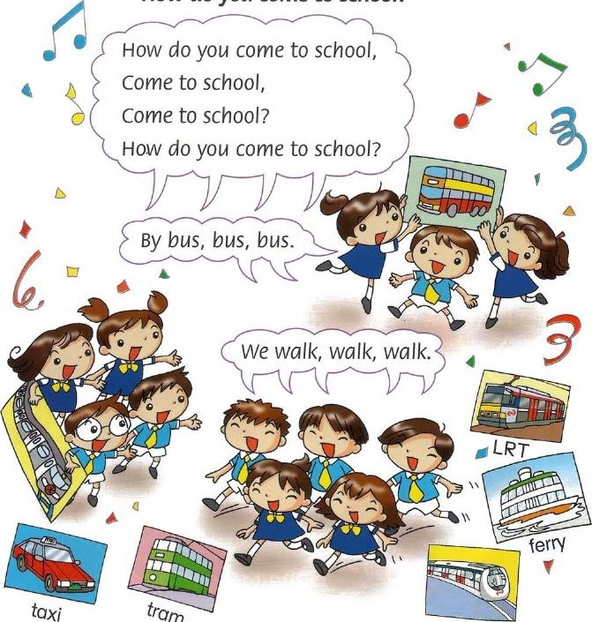

train

Candy is a new girl. She is meeting some new friends. Read.

## New Territories

Sha Tin

Tuen-Muh

Guen Wan Kowloon anny

Mong 60k Kwun Tbnø

Kowloon on Hong Kong Island

the New Territories

Candy Wendy

|  |  |
| --- | --- |
| Betty | sally |
| I live in | I live in |

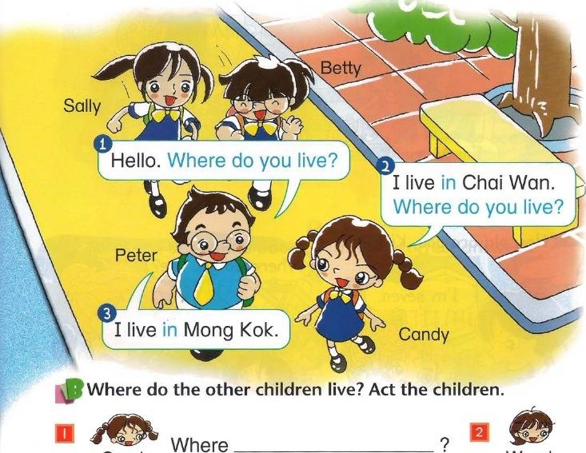1 

Mary Fanny Candy is meeting Betty and Sally. Where do they live? Listen and write the correct answers.

A M to Read c How do Mary and Kitty meet? Read and find out.

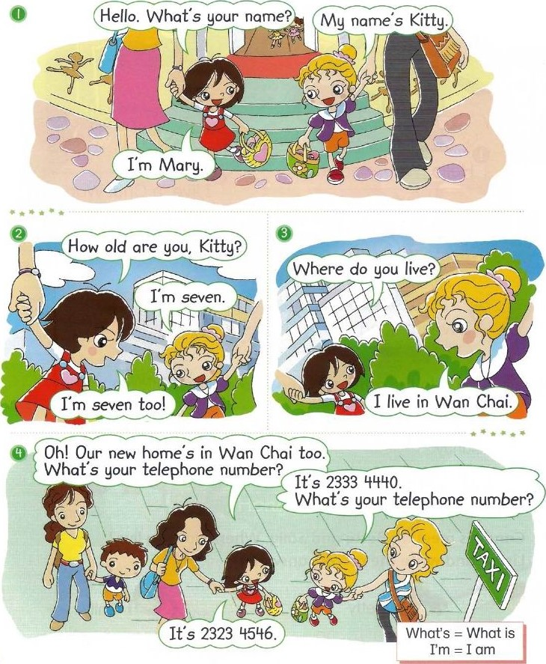

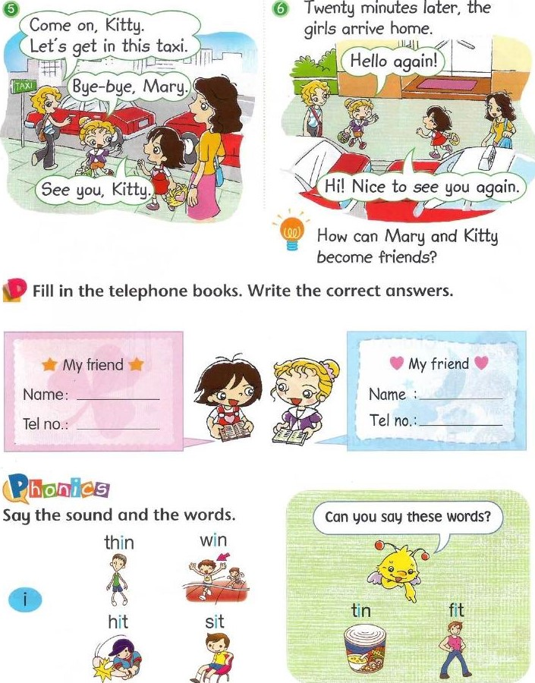

### 10

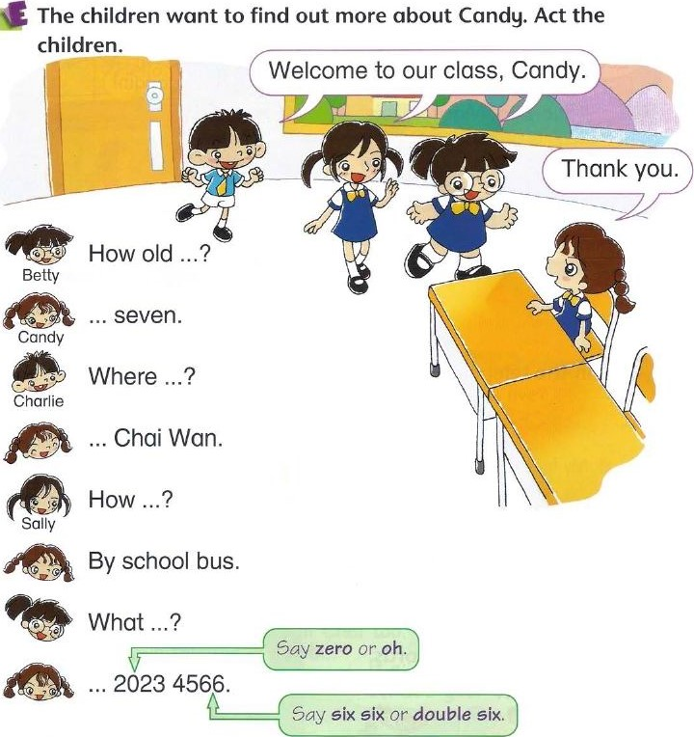

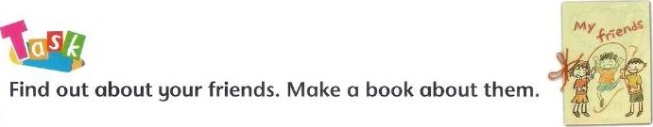Practise the dialogue with your friends. Ask and answer questions.

## anguage

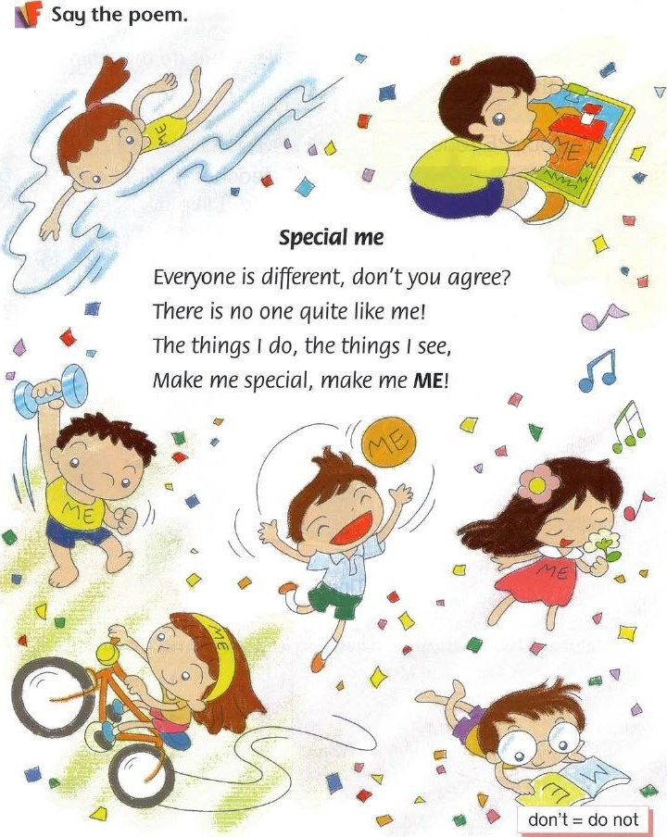

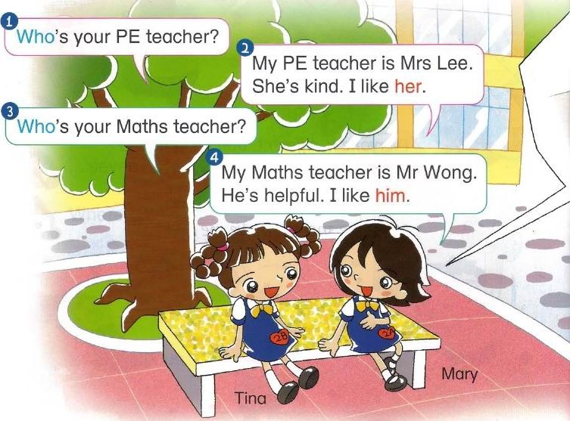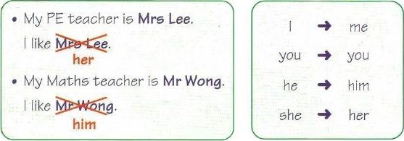about their teachers? Read.

teachers.

's yourteacher?

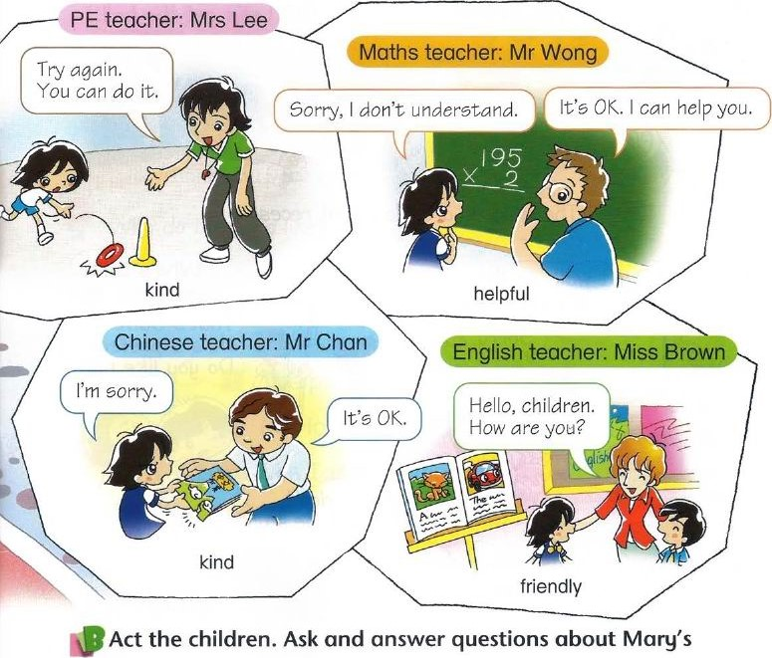Tina

Myteacher is

Mary's. I like

14

## A to•Read

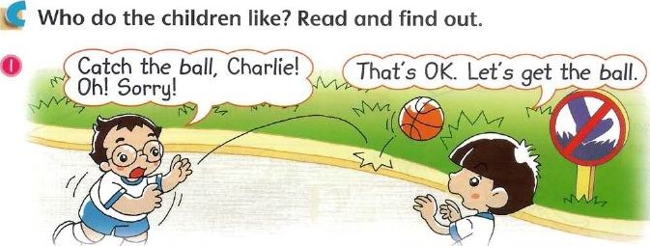

The children are playing at recess.

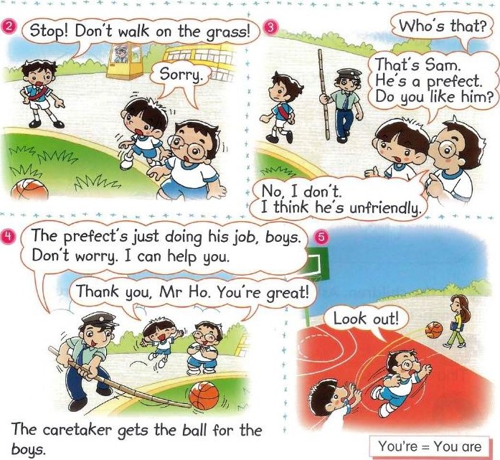

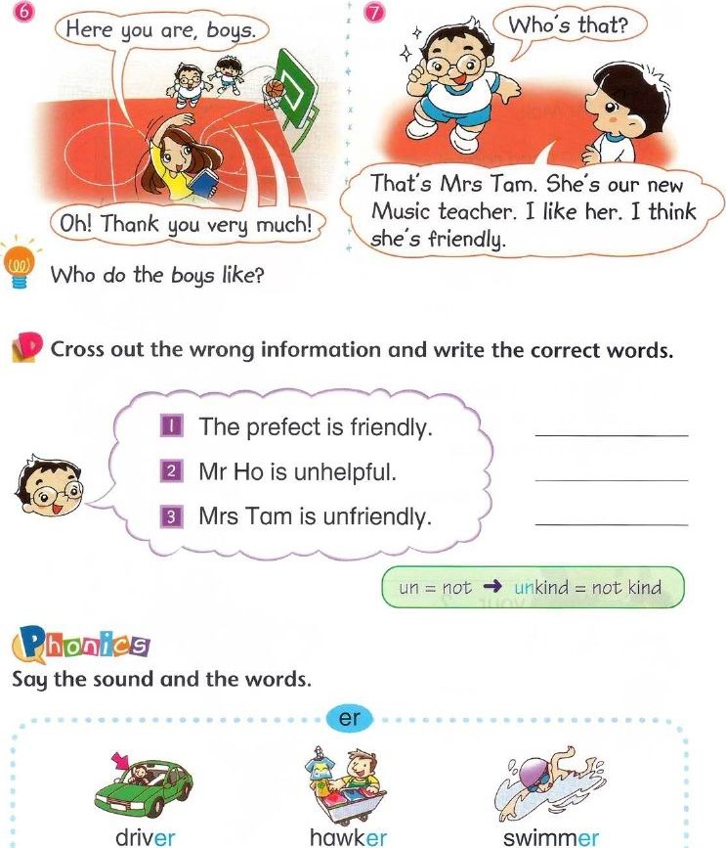

Find two more words with the same sound.

16

Candy and Charlie want to thank people who help them. Look at the notes and act the children.

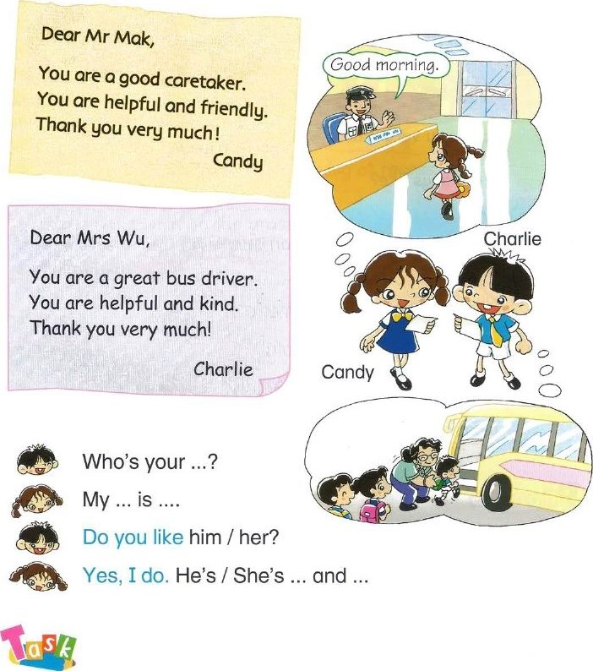

Find out about someone who helps you. Write a note to the person.

17

### ang uage

19

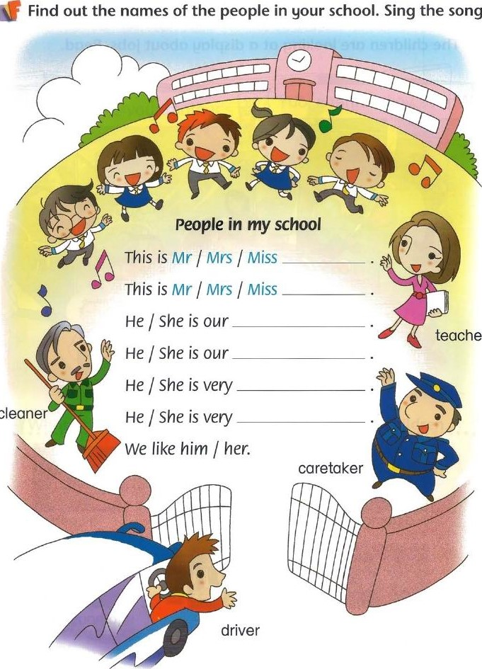

song.

teacher

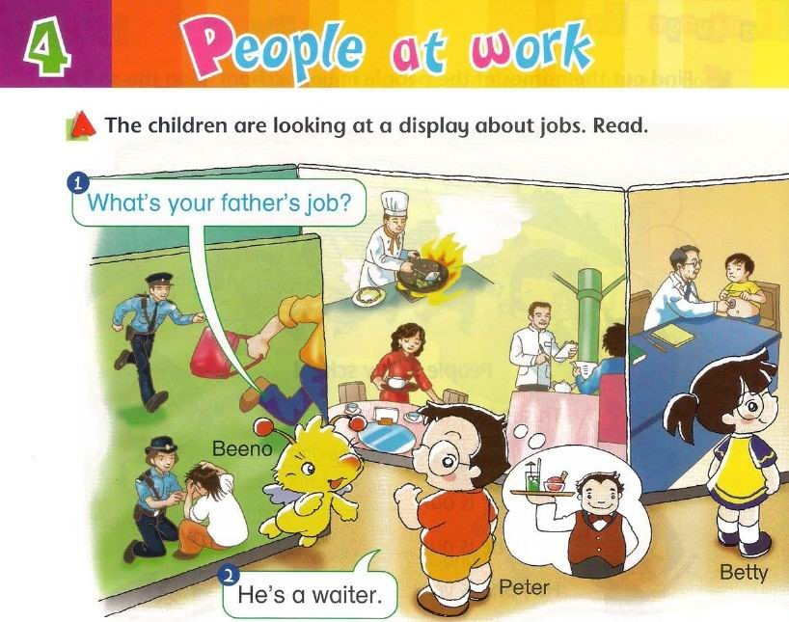

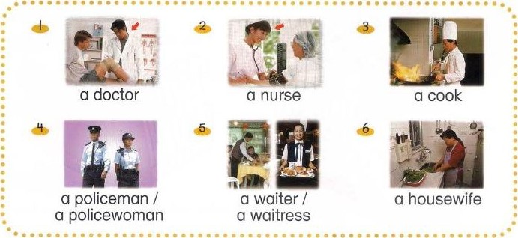

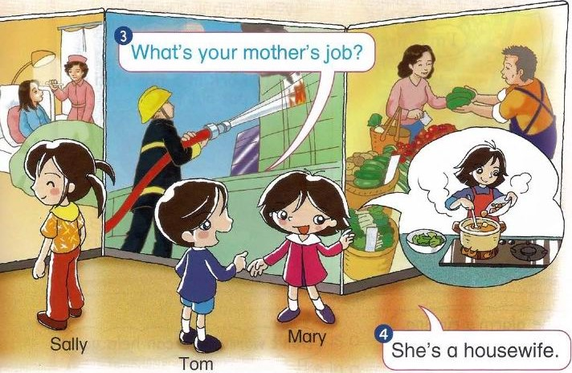• What are their parents' jobs? Act Beeno and the children.

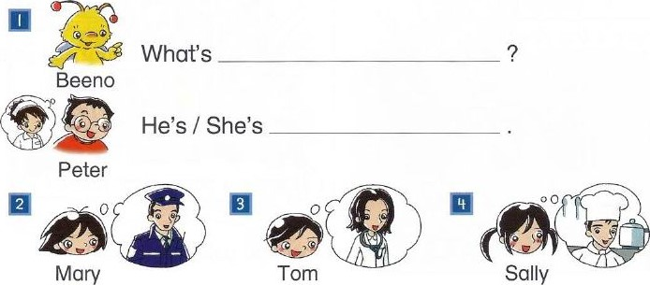

20

A to'Read

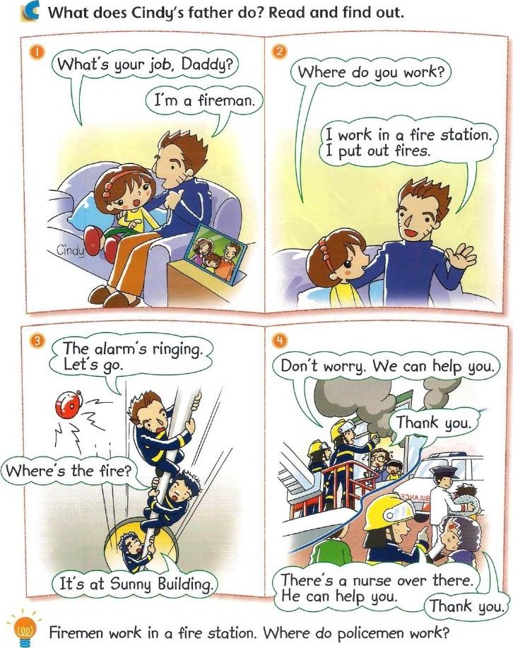

21

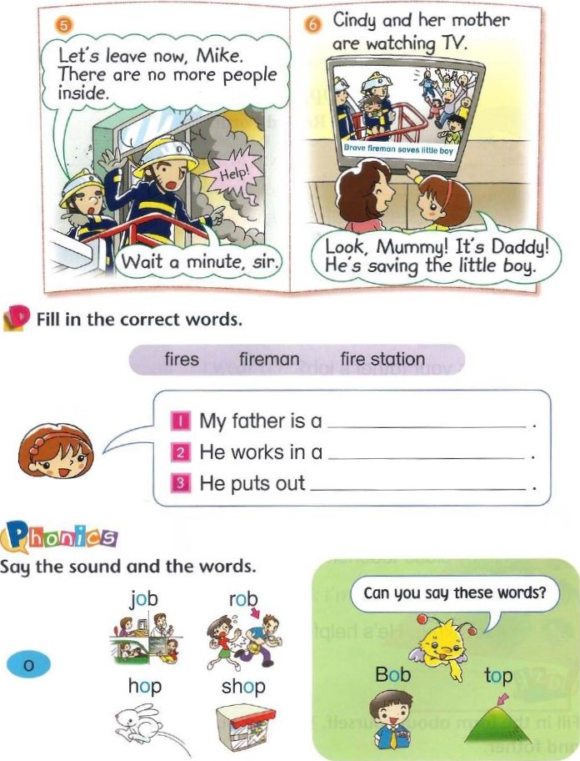

Sally wants to find out more about a new boy. Act the children.

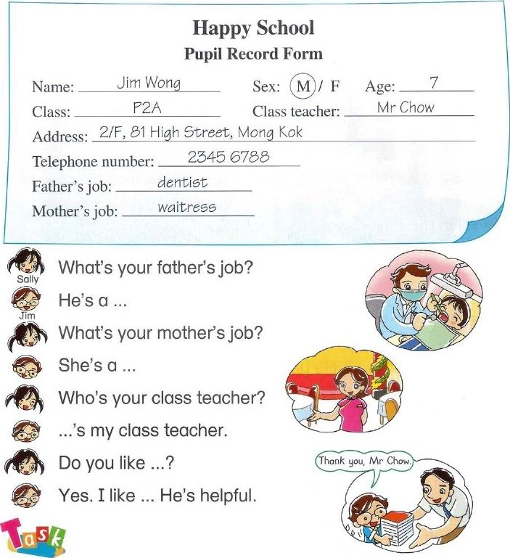What's your father's job?

What's your mother's job?

Who's your class teacher? ...'s my class teacher.

...Q

Yes. I like ... He's helpful.

Fill in the form about yourself. Tell your partner about your mother and father.

•ah 9 uage

Read the rhyme. Write the jobs under the pictures.

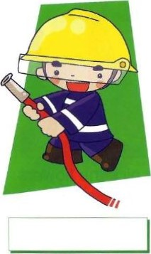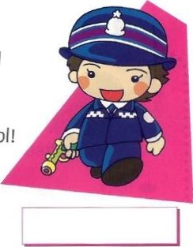Jobs

I am a policewoman.

I have a gun.

I wear a jacket

And I walk in the sun.

I am a fireman.

I have a hose.

I wear a hat

And I cover my nose.

I am a caretaker. I look after my school

I wear a uniform

The kids think I'm cool!

These are rhyming words.

They have the some sounds: gun sun hose nose

school cool

24

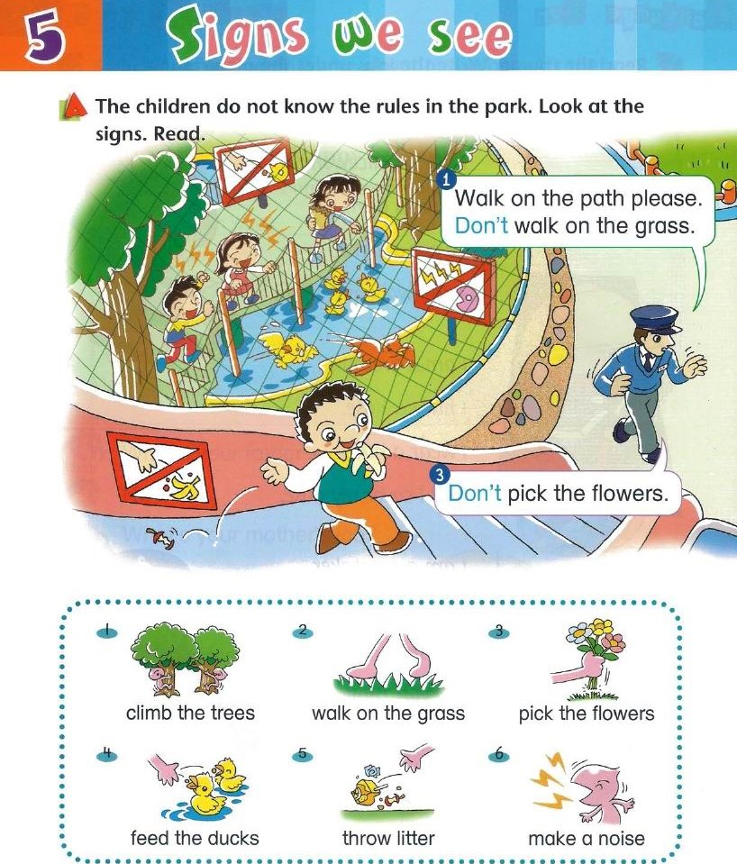



Jack May and Ken

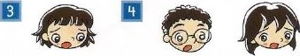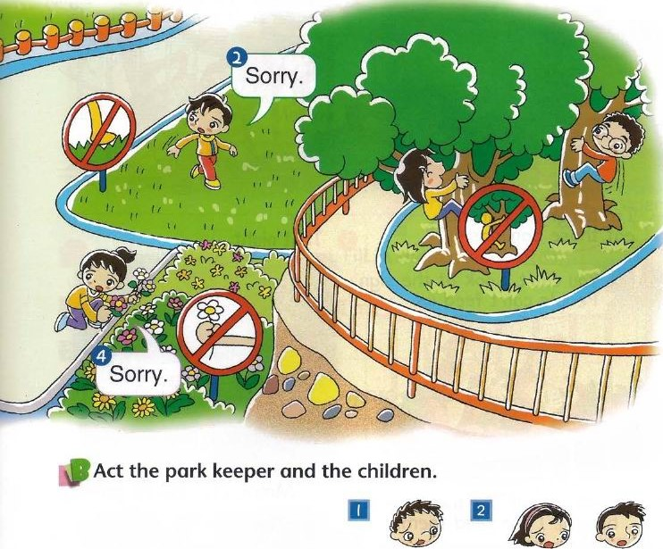Don't

park keeper

Helen Danny and Ann

## to Read

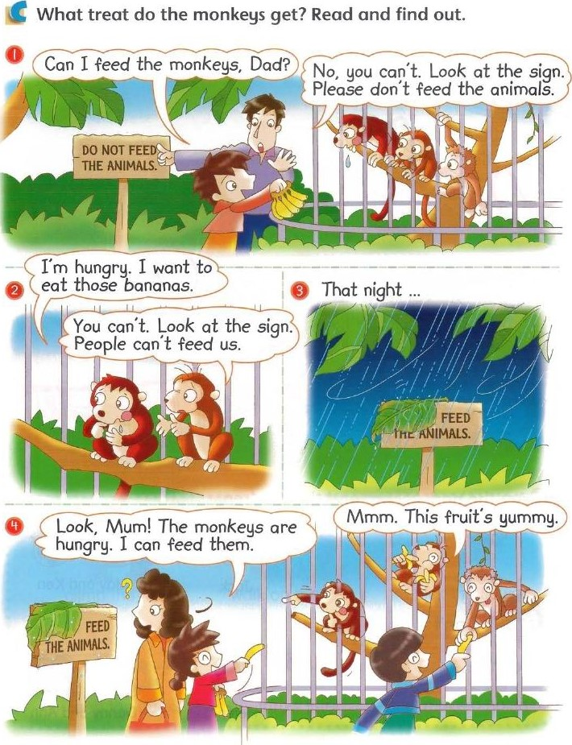

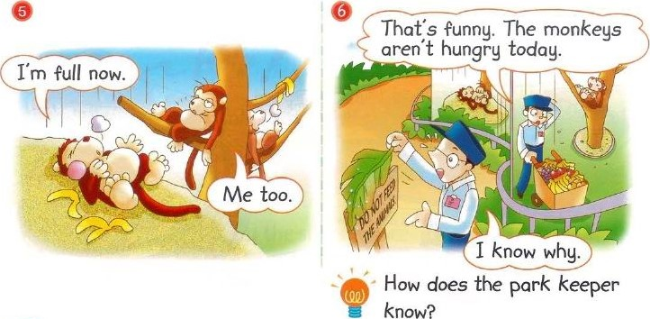

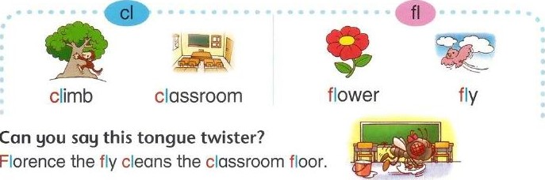Find words from the story. Fill in the correct words.

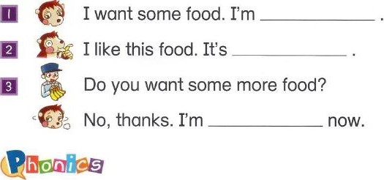

Say the sounds and the words.

29

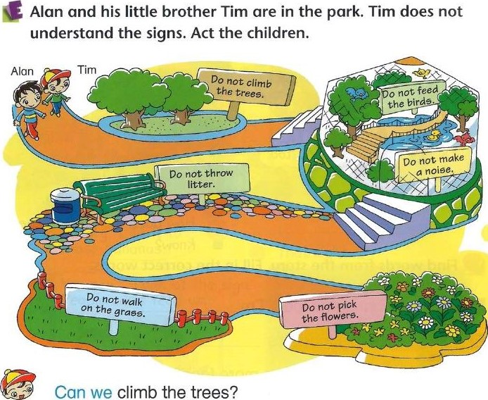

Tim

No, we can't. Look at the sign. It says: Do not climb the

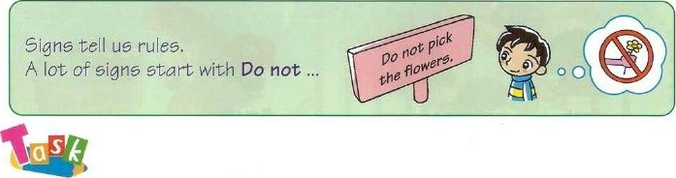 Alan trees.

Talk about rules in the park. Write some signs for the park.

### uage

yo

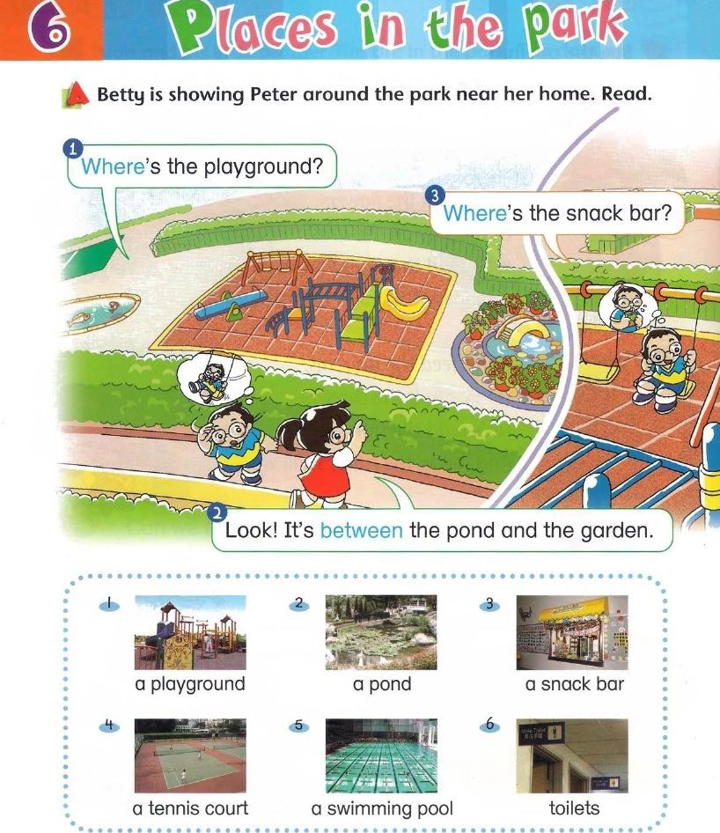

park



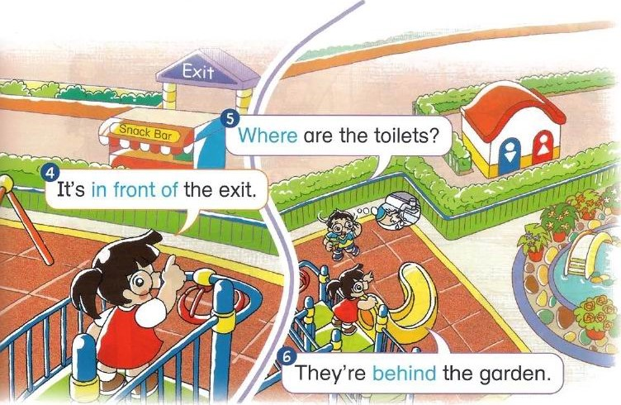• Act Peter and Betty. Ask and answer questions about the other places.

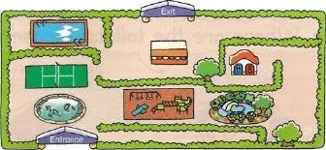

Where's / Where are

It's / They're

CA M to Read c What happens to Charlie and Cherry in the park? Read and find out.

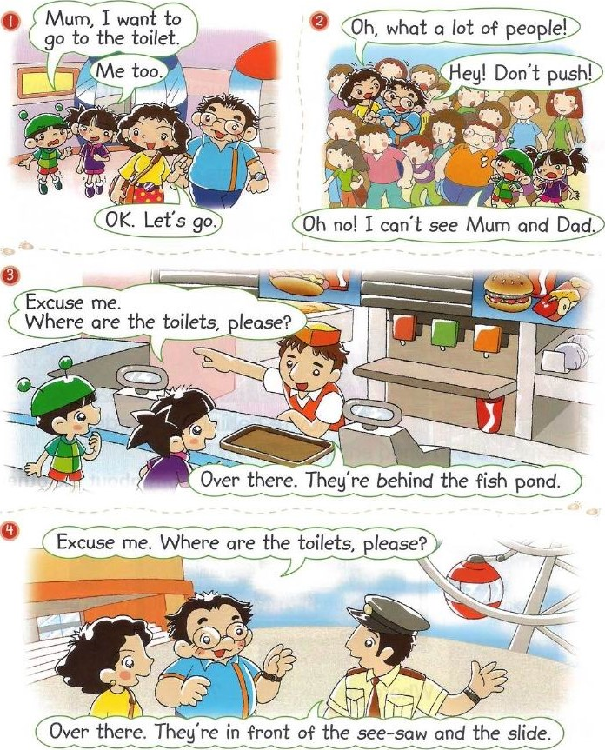

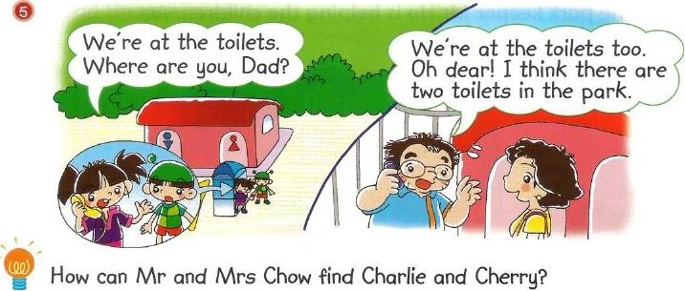

Draw where the people are.

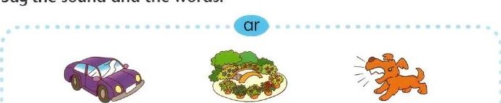 oo= Charlie and Cherry = Mr and Mrs Chow

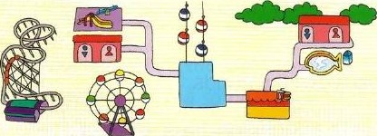

## hon;cs

Say the sound and the words.

car garden bark

Find two more words with the same sound.

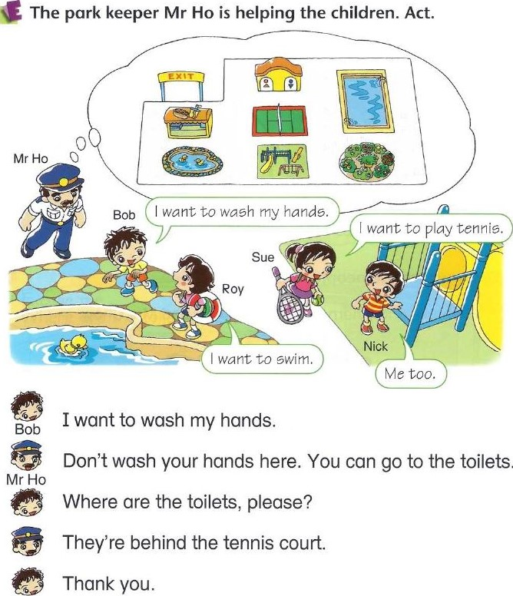

Talk about the things you want to do in the park. Find out where you can do them.

### ang uage Lee

Read the poem.

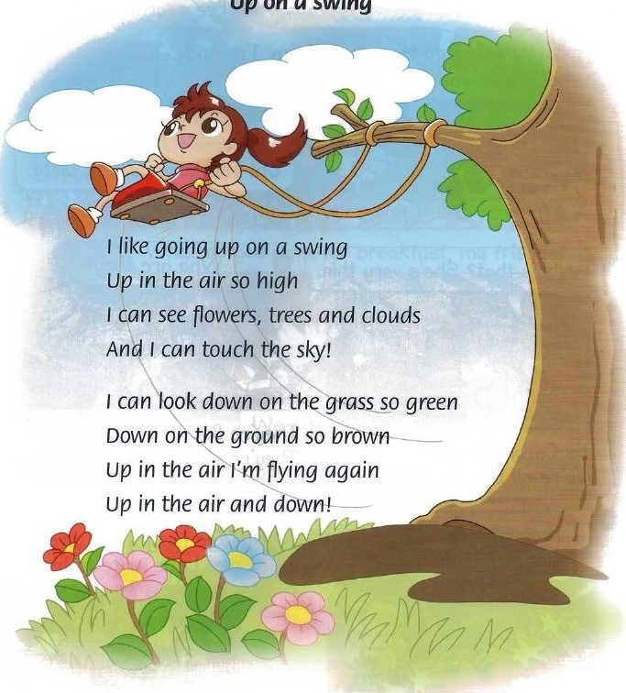

UP

on

a

swing

Write a list of things you can see from a swing.

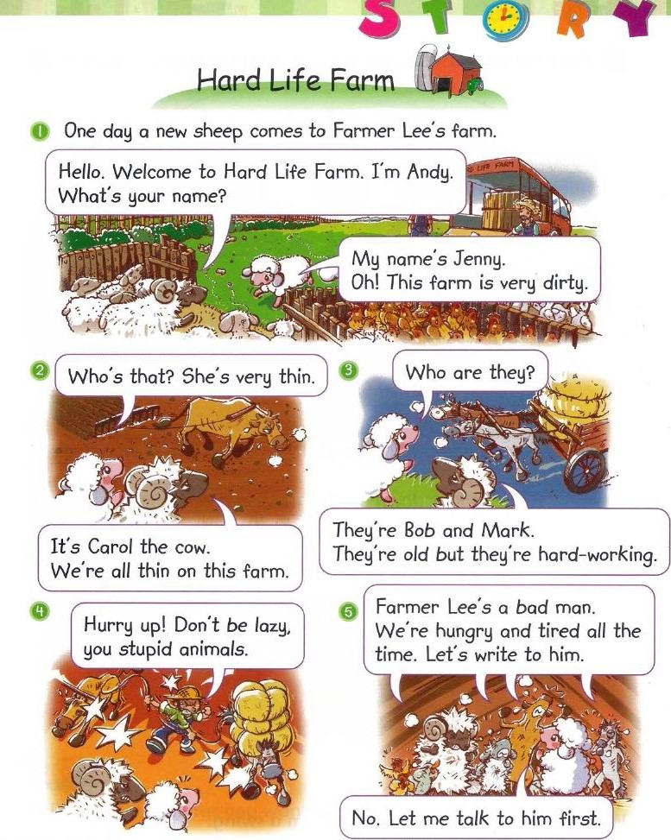

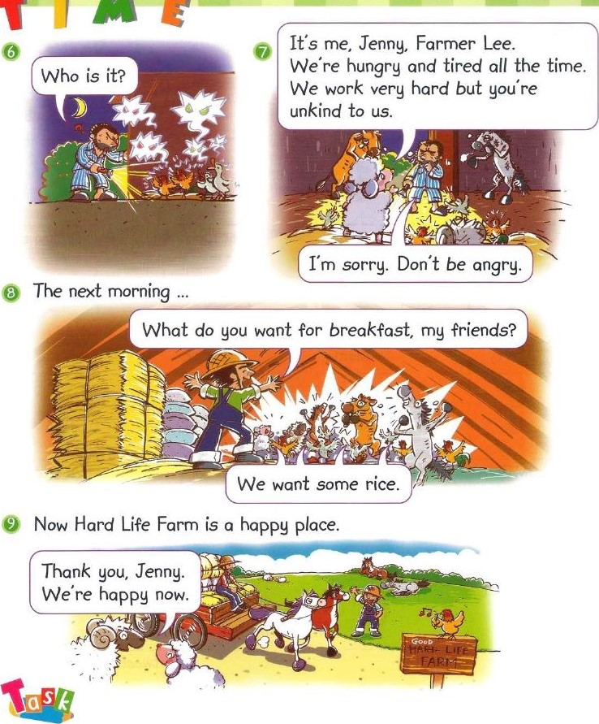

Look at Picture 5. What can the animals write to Farmer Lee? Finish their note.

# iicto e dict onary



a bus a minibus a school bus

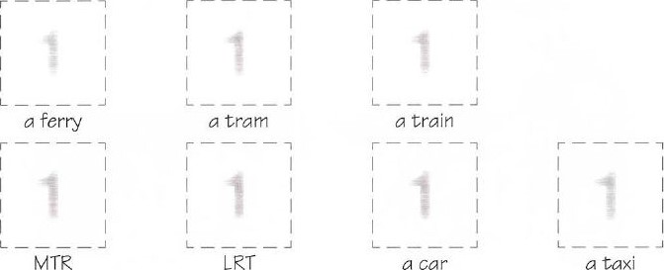



behind

in front of

between



a teacher a bus driver a caretaker a cleaner



o doctor a nurse a dentist

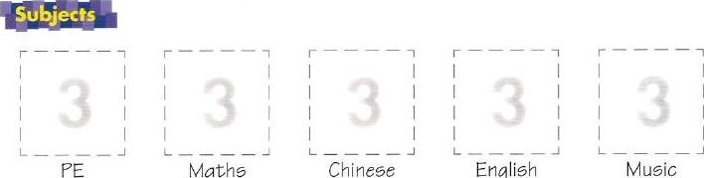

Mathe

Chinese

Music



G cook a policeman a policewoman



a waiter a waitress a housewife a fireman



kind helpful friendly



unfriendly unkind unhelpful



dirty old hard-working



lazy tired angry

## 41

 climb the trees walk on the grass

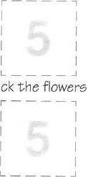

pick

feed the ducks throw litter make a noise

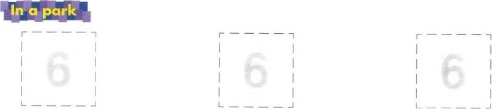

 a playground a pond a snack bar



o tennis court a swimming pool toilets

a garden a see-saw G slide

42

# entractons

I am We are

You are

She is

 They are

## It is

 That is There is  What is Who is

Where is  Let us do not cannot are not

eeggested reading (ist 

For Chapters 1 and 2

Title Text type Author(s) Publisher

Hamster School Bus Christine

Stories Bright Readers — Longman ISBN 9620111796 Bruce

Everybody is Special Marian Shared Reading Programme — Stories

ISBN 9620079582 Lim Addison Wesley Longman

For Chapters 3 and 4

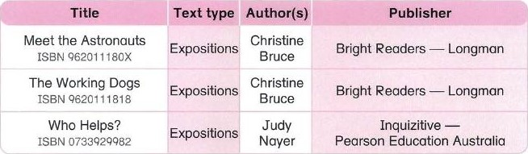

For Chapters 5 and 6

Title

A Farm ISBN 9620111850

|  |  |  |  |
| --- | --- | --- | --- |
| Mack the Quack ISBN 0733938515 | Plays | Bill  Condon | ubliSh  Chatterbox —  Pearson Education Australia |

Rules! Rules!

ISBN 9620111842

In the Playground

ISBN 0733918255

Spy School

ISBN 1869447220

For Storytime

Text type Author(s) Publisher

Stories Christine

Bright Readers — Longman and maps Bruce

Thomas

Rhymes Bright Readers — Longman

Gordon

Personal Christine Inquizitive recounts Economos Pearson Education Australia

Stories with Jill Sailing Solo — messages Eggleton Pearson Education South Asia

Published by

Longman Hong Kong Education

18th Floor. Cornwall House

Taikoo Place

979 King's Road

Hong Kong Tec (852) 3181 and Associated Companies throughout the wond

Longman Website http://vrmv.ilongman.com

E-mail address : info@ilongman.com

O Pearson E-eucotion Asia Limited 2008

rights reserved no part ot this publication may be reproduced stored in a retrieval system or tronsm\fted in anv form or any means, electronic, mechanical photocopying, recording o,' otherwise, without the prior written permission of the Publishers.

First published 200B First reprint 2009

Produced by Longman Hong Kong Education EPC/02

ISBN 978-988-00•1079-8

The Publishers welcome any comments from readers.

Please contact the School Publishing Department on 3 CI]OO or e-mail us at info@ilongman.com

Ac dgements

We are grateful to the following for permission to reproduce copyright photographs:

Corbis far page 19 (a waitress):

Oriental Touch Ltd. for page 19 (a doctor and a nurse):

police Public Relations 3rarch, Hong Kong Police Force, the Government of the Hong Kong Special Administrative Region tor page 19 (a policeman/a policewoman): Taikoo Primary School for page 31 (o snack bar).

Every effort has been made to trace copyright. but in the event of any accidental infringement, we shall be pleased to come to a suitable arrangement with the rightful owner.

PEARSON

Education

Asia

## ee(f-assessment form

|  |  |  |  |
| --- | --- | --- | --- |
| I did well. I could do better.  Chap | | | |
| 1 | • talk about how I come to school How do you come to school?  By MTR. /I come to school on foot. |  |  |
| • talk about where I live Where do you live ?  I live in Chai Wan. |  |  |
| • talk about my telephone number  What is your telephone number?  My telephone number is 2563 1235. |  |  |
| 2 | • talk about people in my school Who's your PE teacher?  My PE teacher is Mr Ho. He's kind. |  |  |
| 3 | • talk about whether I like other people  Do you like him / her?  Yes, I do. / No, I don't. |  |  |
| 4 | • talk about my parents' job  What's your father's / mother's job? He's / She's a cook. |  |  |
| 5 | • write signs for a pork  Do not walk on the grass. |  |  |
| • talk about rules in a park Can we climb the trees?  Yes, we can. / No, we can't. |  |  |
| 6 | • talk about where things are in a park  Where's the playground? It's between the pond and the garden. /  It's in front of the exit. / It's behind the toilets. |  |  |

L a J TUj/P?jDl Wklcome to English

\qtevnauona\

Longman Welcome to English Edition is the latest edition of the highly successful

Welcome to English series for Primary 1 to 6 pupils. It covers the requirements of the English Language Curriculum Guide (Primary 1 to 6) 2004.

Longman Welcome to English uses a rich variety of text types and cross-curricular topics to help pupils learn and master the use of English in a systematic way, and to expand their interests and knowledge. Pupils also have ample opportunity to develop different generic skills, and their critical thinking ability and creativity. The course is also carefully written to nurture positive values and attitudes in pupils in the context of stimulating and fun-filled learning activities.

Key features Of the Pupil's Book include:

* Authentic and interesting contexts • Systematic introduction of phonics skills and to present the language and vocabulary-building skills to facilitate lifelong vocabulary items learning
* Well-balanced teaching and practice • Enjoyable language arts activities and games of the four skills to help pupils enjoy and appreciate English
* Explicit teaching of different text types • A variety of cross-curricular topics for life— to enhance 'learning to read' wide learning
* Concise grammar notes to foster • Supported by a select list of Perfect Match independent learning readers to promote a •reading to learn' culture

For pupils, each level of Longman Welcome to English offers:

* Pupil's Books • Self-study Books
* Pre-task Language Practice • Audio CDs (English & bilingual)

|  |  |
| --- | --- |
| • Listening Skills | • E-Books |
| • Reading & Writing Skills | • Online Self-learning Centre |
| • Grammar Practice | • E-Homework |
| • Territory-wide System | • E-Dictation |
| Assessment Mock Papers | • A Passage a Week |

* E-Writing Class

Visit our companion website at http://lwte.ilongman.com

|  |  |  |  |  |
| --- | --- | --- | --- | --- |
| for up-to-date learning resources and information. | | ISBN | 978-988-00-1079-8 |  |
|  | Name ) Class |
|  |  | | |

PEARSON

Longman Y]-k